Constructing Angle Bisector

Definition
# Source: AI Source: Provided by: [Data Path: Persons Table -> ID Column: 1, Name_En Column: Motasem Essam] -> From: [ChatGPT] on [7/25/2026]
Constructing an Angle Bisector is the geometric construction of a ray or line that divides a given angle into two equal angles.
For an angle $∠ABC$, if ray $\vec{BD}$bisects the angle, then:
$$\boxed{∠ABD=∠DBC}$$
Therefore:
$$\boxed{∠ABC=2∠ABD=2∠DBC}$$
The point $B$is the vertex of the angle, and $\vec{BD}$is the angle bisector.
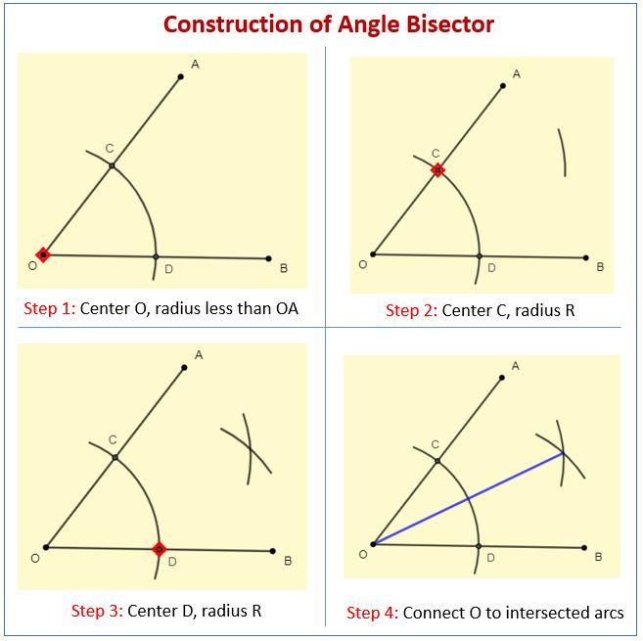
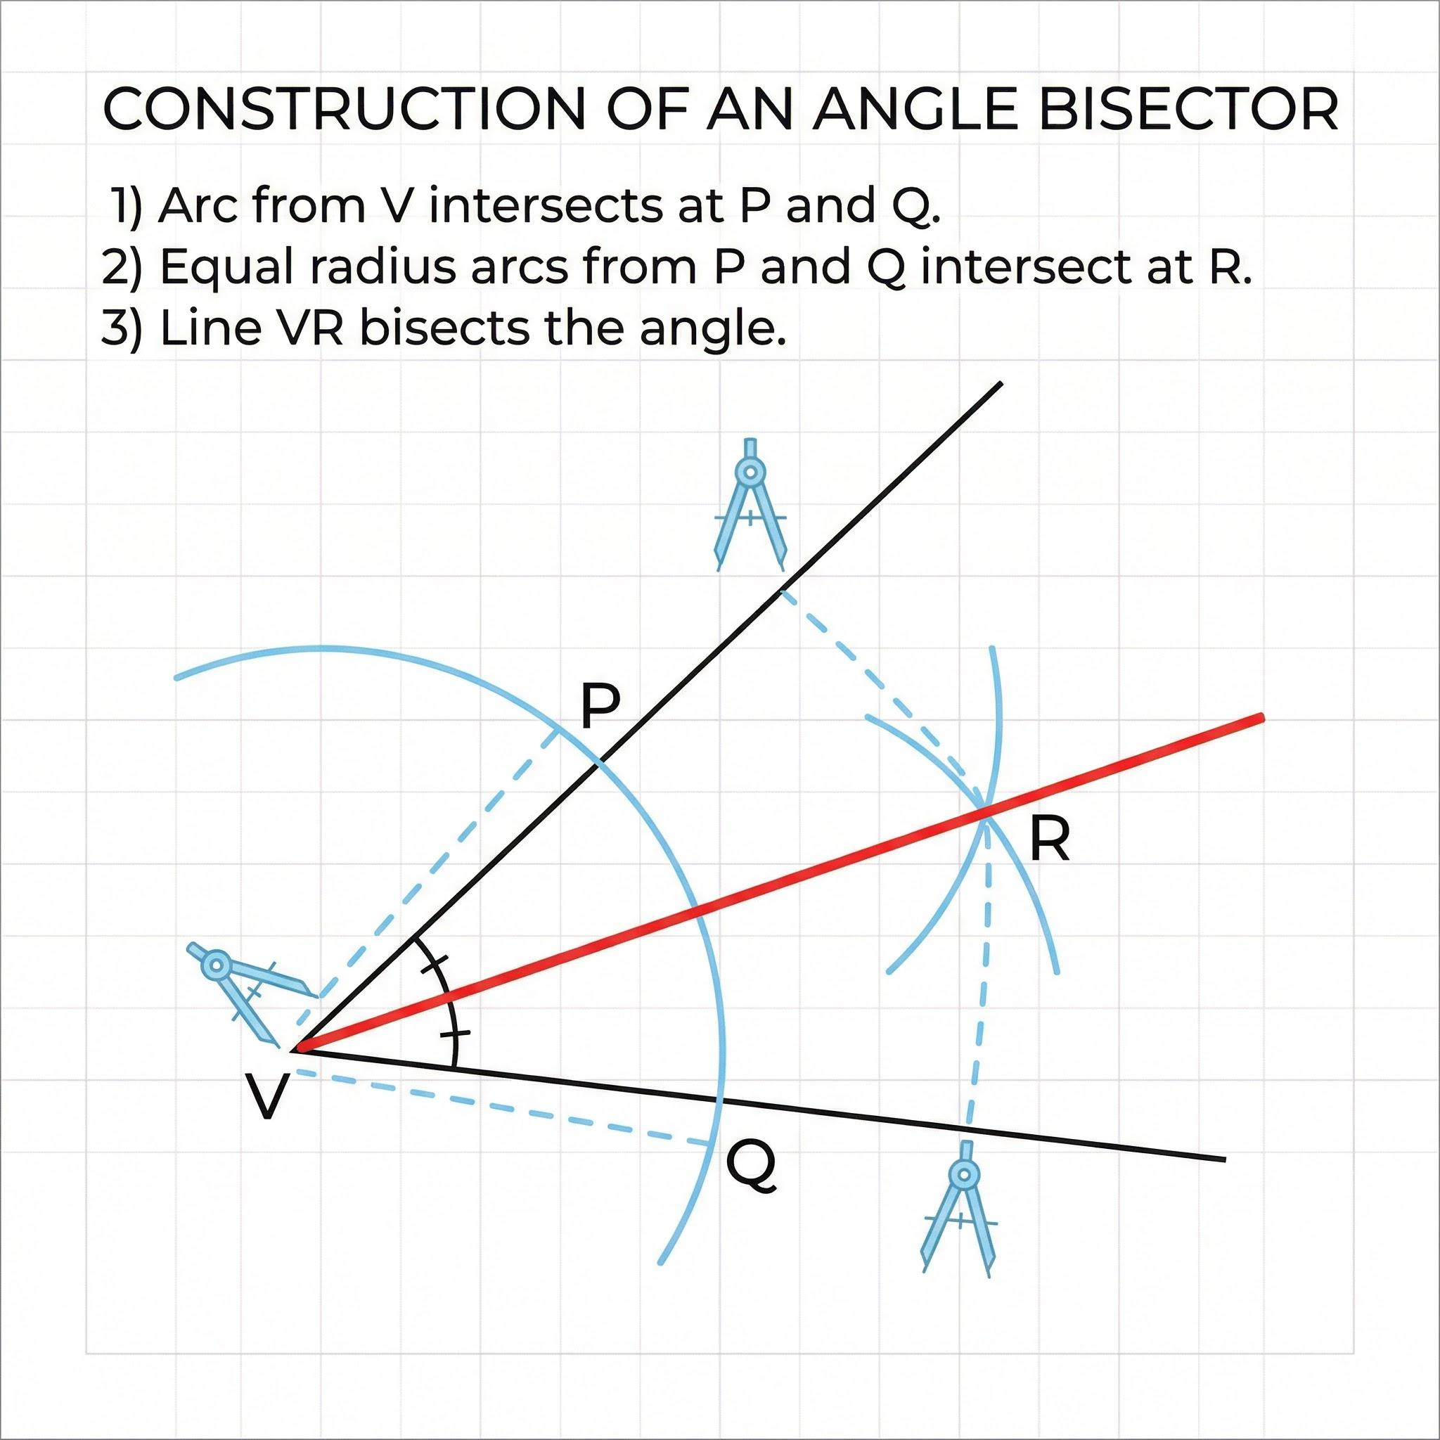
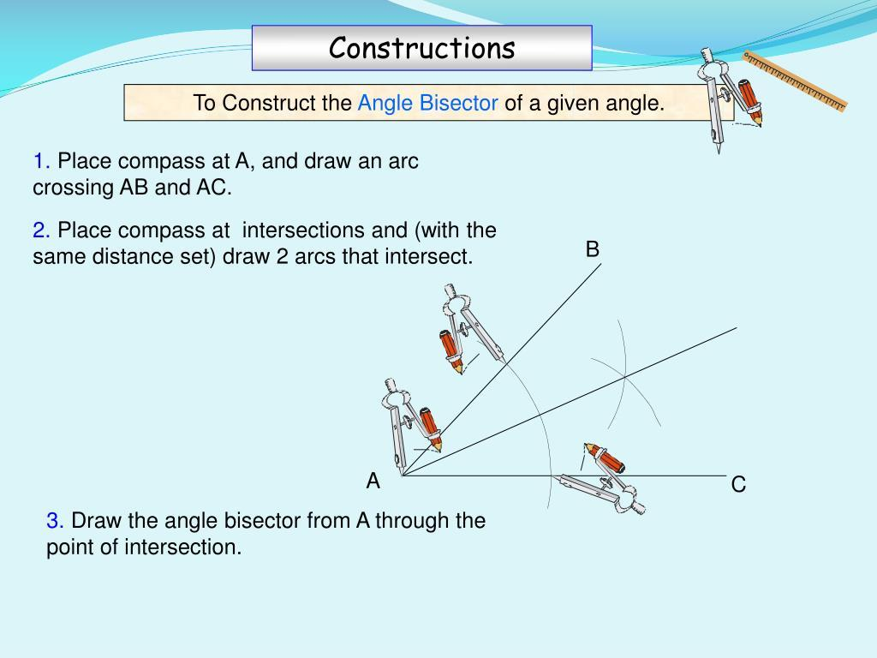

Fundamental Concept
# Source: AI Source: Provided by: [Data Path: Persons Table -> ID Column: 1, Name_En Column: Motasem Essam] -> From: [ChatGPT] on [7/25/2026]
An angle bisector divides an angle into two congruent angles.
Given:
$$∠ABC$$
construct a ray:
$$\vec{BD}$$
such that:
$$\boxed{∠ABD=∠DBC}$$
For example, if:
$$∠ABC={80}^{∘}$$
then:
$$∠ABD=∠DBC={40}^{∘}$$

Basic Construction
# Source: AI Source: Provided by: [Data Path: Persons Table -> ID Column: 1, Name_En Column: Motasem Essam] -> From: [ChatGPT] on [7/25/2026]
Suppose $∠ABC$is the given angle.
Steps
- Place the compass point at the vertex $B$.
- Draw an arc that intersects the two sides of the angle at $P$and $Q$.
- Without changing the compass width, place the compass point at $P$.
- Draw an arc inside the angle.
- Using the same compass width, place the compass point at $Q$.
- Draw another arc that intersects the previous arc at $D$.
- Use a straightedge to draw the ray $\vec{BD}$.
- The ray $BD$is the angle bisector.
Therefore:
$$\boxed{∠ABD=∠DBC}$$
Construction Diagram
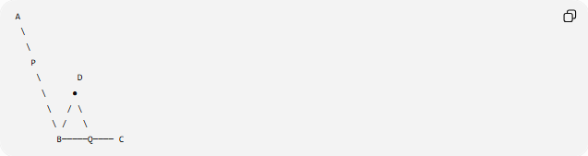
A
\
\
P
\ D
\ ●
\ / \
\ / \
B─────Q──── C
The ray from $B$through $D$divides the original angle into two equal angles.

Why the Construction Works
# Source: AI Source: Provided by: [Data Path: Persons Table -> ID Column: 1, Name_En Column: Motasem Essam] -> From: [ChatGPT] on [7/25/2026]
The first arc creates:
$$BP=BQ$$
because both points lie on the same circle centered at $B$.
The second pair of arcs creates:
$$PD=QD$$
because the same compass width is used.
Also:
$$BD=BD$$
because it is the common side.
Therefore, the triangles:
$$△BPD$$
and:
$$△BQD$$
are congruent by SSS:
$$\boxed{△BPD≅△BQD}$$
Consequently:
$$\boxed{∠PBD=∠DBQ}$$
Since $P$lies on ray $BA$and $Q$lies on ray $BC$:
$$\boxed{∠ABD=∠DBC}$$
Thus, $BD$is the angle bisector.

Mathematical Representation
# Source: AI Source: Provided by: [Data Path: Persons Table -> ID Column: 1, Name_En Column: Motasem Essam] -> From: [ChatGPT] on [7/25/2026]
For:
$$∠ABC=θ$$
the angle bisector divides it into:
$$\boxed{\frac{θ}{2}}$$
and:
$$\boxed{\frac{θ}{2}}$$
Therefore:
$$\boxed{∠ABD=∠DBC=\frac{∠ABC}{2}}$$

Types of Angle Bisector Construction
# Source: AI Source: Provided by: [Data Path: Persons Table -> ID Column: 1, Name_En Column: Motasem Essam] -> From: [ChatGPT] on [7/25/2026]
The construction can be organized according to the type of angle being bisected:
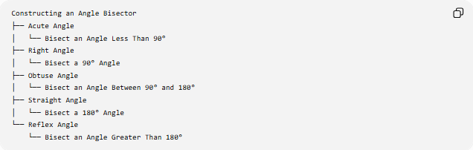
Constructing an Angle Bisector
├── Acute Angle
│ └── Bisect an Angle Less Than 90°
├── Right Angle
│ └── Bisect a 90° Angle
├── Obtuse Angle
│ └── Bisect an Angle Between 90° and 180°
├── Straight Angle
│ └── Bisect a 180° Angle
└── Reflex Angle
└── Bisect an Angle Greater Than 180°
The standard classical construction is most commonly applied to angles from $0^{∘}$to ${180}^{∘}$.
Classification note: These are classifications according to the measure of the angle being bisected, not different mathematical types of angle-bisector lines.

Special Cases

1. Bisecting a Right Angle
# Source: AI Source: Provided by: [Data Path: Persons Table -> ID Column: 1, Name_En Column: Motasem Essam] -> From: [ChatGPT] on [7/25/2026]
For:
$$∠ABC={90}^{∘}$$
the angle bisector creates:
$$\boxed{{45}^{∘}+{45}^{∘}}$$

2. Bisecting a Straight Angle
# Source: AI Source: Provided by: [Data Path: Persons Table -> ID Column: 1, Name_En Column: Motasem Essam] -> From: [ChatGPT] on [7/25/2026]
For:
$$∠ABC={180}^{∘}$$
the bisector creates:
$$\boxed{{90}^{∘}+{90}^{∘}}$$
Thus, the angle bisector of a straight angle is a perpendicular line.

Repeated Angle Bisection
# Source: AI Source: Provided by: [Data Path: Persons Table -> ID Column: 1, Name_En Column: Motasem Essam] -> From: [ChatGPT] on [7/25/2026]
An angle can be bisected repeatedly.
For an angle of ${90}^{∘}$:
$${90}^{∘}→{45}^{∘}→{22.5}^{∘}→{11.25}^{∘}$$
In general, after $n$successive bisections:
$$\boxed{θ_{n}=\frac{θ}{2^{n}}}$$
For example, starting with ${60}^{∘}$:
$${60}^{∘}→{30}^{∘}→{15}^{∘}→{7.5}^{∘}$$

Angle Bisector vs Perpendicular Bisector
# Source: AI Source: Provided by: [Data Path: Persons Table -> ID Column: 1, Name_En Column: Motasem Essam] -> From: [ChatGPT] on [7/25/2026]
These constructions are different.
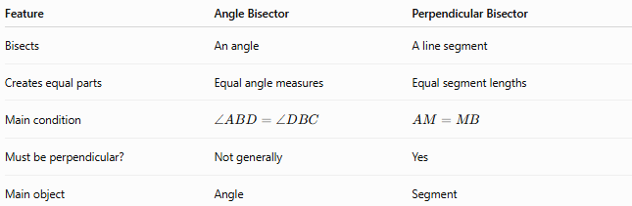
Feature | Angle Bisector | Perpendicular Bisector
Bisects | An angle | A line segment
Creates equal parts | Equal angle measures | Equal segment lengths
Main condition | $$∠ABD=∠DBC$$ | $$AM=MB$$
Must be perpendicular? | Not generally | Yes
Main object | Angle | Segment
Therefore:
$$\boxed{\text{Angle Bisector}≠\text{Perpendicular Bisector}}$$
Although both use the word bisector, they bisect different geometric objects.

Angle Bisector vs Perpendicular Line
# Source: AI Source: Provided by: [Data Path: Persons Table -> ID Column: 1, Name_En Column: Motasem Essam] -> From: [ChatGPT] on [7/25/2026]
An angle bisector does not necessarily form a ${90}^{∘}$angle with either side.
Its defining condition is:
$$\boxed{∠ABD=∠DBC}$$
A perpendicular line is defined by:
$$\boxed{∠={90}^{∘}}$$
However, the bisector of a straight angle does form ${90}^{∘}$angles with the two opposite rays.

Angle Bisector Theorem
# Source: AI Source: Provided by: [Data Path: Persons Table -> ID Column: 1, Name_En Column: Motasem Essam] -> From: [ChatGPT] on [7/25/2026]
The Angle Bisector Theorem describes the relationship between an angle bisector in a triangle and the opposite side.
In triangle $ABC$, if $AD$bisects $∠A$and meets $BC$at $D$, then:
$$\boxed{\frac{BD}{DC}=\frac{AB}{AC}}$$
This theorem is different from the construction of an angle bisector.
Construction vs Theorem
Construction:
Shows how to create the angle bisector.
Angle Bisector Theorem:
Describes the ratio in which the angle bisector divides the opposite side.

Applications
# Source: AI Source: Provided by: [Data Path: Persons Table -> ID Column: 1, Name_En Column: Motasem Essam] -> From: [ChatGPT] on [7/25/2026]
Angle bisectors are used to construct:
- equal angles
- special angles
- triangle angle bisectors
- incenter of a triangle
- incircles
- angles obtained through repeated bisection
Incenter
The three internal angle bisectors of a triangle intersect at a single point called the incenter.
$$\boxed{\text{Incenter}=\text{intersection of the internal angle bisectors}}$$
The incenter is equidistant from all three sides of the triangle.

Tools Used
# Source: AI Source: Provided by: [Data Path: Persons Table -> ID Column: 1, Name_En Column: Motasem Essam] -> From: [ChatGPT] on [7/25/2026]
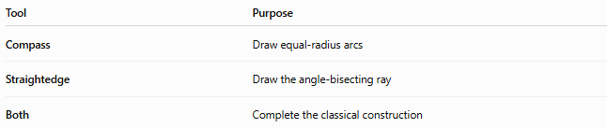
Tool | Purpose
Compass | Draw equal-radius arcs
Straightedge | Draw the angle-bisecting ray
Both | Complete the classical construction
The compass is essential for transferring equal distances during the construction.

Classification Summary
# Source: AI Source: Provided by: [Data Path: Persons Table -> ID Column: 1, Name_En Column: Motasem Essam] -> From: [ChatGPT] on [7/25/2026]
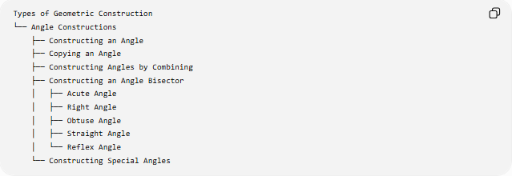
Types of Geometric Construction
└── Angle Constructions
├── Constructing an Angle
├── Copying an Angle
├── Constructing Angles by Combining
├── Constructing an Angle Bisector
│ ├── Acute Angle
│ ├── Right Angle
│ ├── Obtuse Angle
│ ├── Straight Angle
│ └── Reflex Angle
└── Constructing Special Angles

Key Points
# Source: AI Source: Provided by: [Data Path: Persons Table -> ID Column: 1, Name_En Column: Motasem Essam] -> From: [ChatGPT] on [7/25/2026]
- An angle bisector divides an angle into two equal angles.
- For $∠ABC$:
$$\boxed{∠ABD=∠DBC}$$
- Each resulting angle has measure:
$$\boxed{\frac{∠ABC}{2}}$$
- The classical construction uses a compass and straightedge.
- Equal-radius arcs are used to establish the required symmetry.
- The two resulting triangles are congruent by SSS.
- Repeated bisection produces angles of:
$$\boxed{\frac{θ}{2^{n}}}$$
- The internal angle bisectors of a triangle meet at its incenter.
- An angle bisector and a perpendicular bisector are different constructions.

Conclusion
# Source: AI Source: Provided by: [Data Path: Persons Table -> ID Column: 1, Name_En Column: Motasem Essam] -> From: [ChatGPT] on [7/25/2026]
Constructing an Angle Bisector is the process of constructing a ray that divides a given angle into two congruent angles. The classical compass-and-straightedge construction uses equal-radius arcs to establish symmetry, and the resulting ray passes through the vertex and divides the original angle exactly in half. Angle bisectors are fundamental to angle construction, triangle geometry, the construction of the incenter, and repeated angle bisection.

